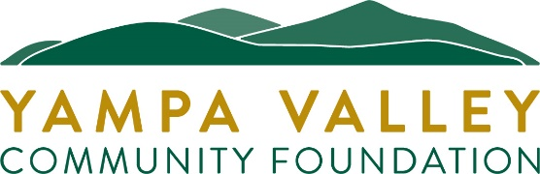

YVCF Community Grants - Reporting Form (UPDATED FOR 2025-26)
DUE 6/1/26 or at the conclusion of efforts funded by this grant, whichever is earliest.
PLEASE SIGN AND DATE FORM WHEN COMPLETE
No further YVCF Community Grant requests will be considered until this report has been completed and returned.

Name of Organization:
Contact Name:
Email:
Grant Amount:

Dates of efforts supported through this grant:
Amount of grant funds remaining as of this report:
If grant funds remain, expected date they will have been spent:

NARRATIVE
What would you like us to know about your work and what has happened in your organization over the past year? If you received a PROGRAM grant, you must include these details:
- How these funds supported the proposed program
- How you honored restrictions, if any (e.g., if funds were for use only in Routt and/or Moffat County)
- Any results or outcomes that you can share

Optional: How else can the Community Foundation help?

I hereby certify that the above and attached statements are true and accurate.

Signed Date

Print Name: Title:

If you would like to attach additional material, you may include up to 2 letter-sized pages (4 pages maximum).
If applying for a 2026-27 Community Grant, attach a PDF of completed form to your new application in the web portal, after Question #29, by the deadline of 6/1/26. If not reapplying or if efforts funded by this grant conclude earlier than June, 2026, please email form to: camille@yvcf.org

